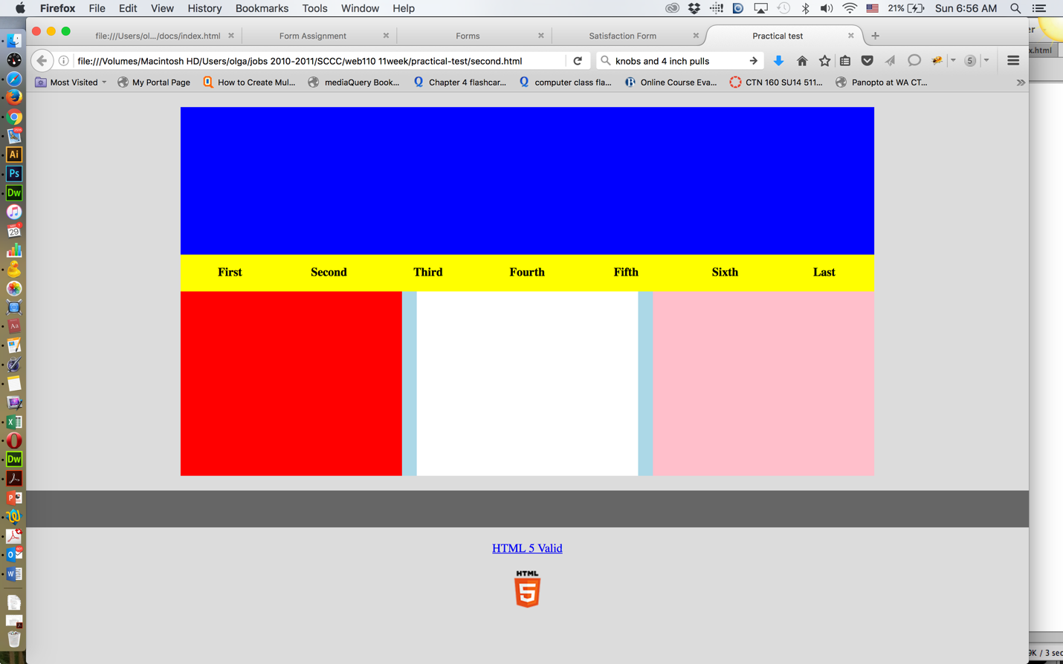

FOR EXTRA CREDIT... display the HTML5 image below HTML5 Valid!
Here is the image!

Question 1
10 / 40 pts
Does your HTML page resemble the screenshot? Colors and sizes?
Please upload your file!

Question 2
10 / 20 pts
Are the navigation list items displayed correctly (The correct color and width)? I s the background color and text color changing when hovering over the list item? Don't forget the "anchor!"
Please upload the same file!
practical_test_1.html

Question 3
10 / 10 pts
Correct placement of the footer.
Please upload the same file!
practical_test_1.html

Question 4
10 / 10 pts
Upload your file onto our server, AND type your url here!
It would look like this:
http://central.mystudentswa.com/username/it161/whateveryoucalledthispage.html

Your Answer:
http://central.mystudentswa.com/williamgo/it161/practical_test_1.html

Question 5
0 / 10 pts
Display the test under your list of assignments on your PORTAL PAGE, and link it!
Upload the same file one more time!
Not listed on your portal page

Question 6
5 / 10 pts
Validation link and it validates!
Validated, but no link.
Quiz Score: 45 out of 100

